PROJECT REPORT
ON
INTERNSHIP PROJECT 2
PERSONAL EXPENSE TRACKER USING HTML, CSS, JAVASCRIPT, JQUERY, AND BOOTSTRAP 5</p>
IN THE DOMAIN OF
FRONT-END WEB DEVELOPMENT
BY
ANANYA MAURYA
DATE: 24-08-2025

TABLE OF CONTENTS
S. No | Topic | Page no.
1. | Abstract | 3
2. | Objectives | 4
3. | Introduction | 6
4. | Methodology | 7
5. | Code | 11
6. | Results and Outputs | 19
7. | Conclusion | 20

ABSTRACT

This report outlines the design and development of a Personal Expense Tracker application, a web-based tool created to help users monitor and manage their daily expenditures. The project is built using fundamental front-end technologies, including HTML for structuring the content, CSS for styling, and JavaScript with jQuery for handling the application's logic and user interactions. The responsive and mobile-first user interface is powered by the Bootstrap 5 framework, ensuring a seamless experience across all devices, from desktops to smartphones.
The core functionalities of the application allow users to add new expenses with details such as a description, category, amount, and date. Users can also view a comprehensive list of all their expenses, edit the details of any existing entry, and delete expenses that are no longer needed. To ensure data persistence, the application leverages the browser's LocalStorage API, which saves all expense data directly on the user's device. This allows users to close their browser or refresh the page and have their data readily available upon their return, without the need for a backend server or database.
The application also incorporates features for data analysis, including a dynamic summary that displays the total expenses and a filtering mechanism that allows users to view expenses by a specific category. This combination of features provides a robust and user-friendly solution for effective personal finance management.

OBJECTIVE

The primary goal of the Personal Expense Tracker project is to develop a functional, intuitive, and efficient tool for personal financial management. The following objectives were established to guide the development process:-

1. User-Friendly Interface
The foremost objective is to design and craft a clean, intuitive, and user-friendly interface. The application should allow users to interact with their financial data effortlessly. This includes easy navigation, clear visual cues for adding, editing, and deleting expenses, and a logical layout that minimizes cognitive load, enabling users to manage their finances quickly and efficiently.

2. Core Expense Management Functionalities
To be an effective tool, the application must provide robust CRUD (Create, Read, Update, Delete) functionalities for expenses. This includes:
- Adding Expenses: A simple form to input expense details like description, category, amount, and date.
- Viewing Expenses: A clear, tabular display of all logged expenses, sorted chronologically.
- Editing Expenses: The ability to modify the details of any previously entered expense.
- Deleting Expenses: A straightforward way to remove individual expenses from the list.

3. Data Persistence with LocalStorage
A critical objective is to ensure that user data is not lost between sessions. By implementing the browser's LocalStorage, the application reliably saves all expense entries on the user's local machine. This allows users to close the application and return later to find their data intact, providing a consistent and dependable user experience without requiring a backend infrastructure.

4. Responsive Design
The application must be fully accessible and functional across a wide range of devices. By leveraging the Bootstrap 5 framework, a key objective is to implement a responsive, mobile-first design. The interface should adapt seamlessly to different screen sizes, including desktops, tablets, and smartphones, ensuring a consistent and optimized user experience regardless of the device being used.

5. Data Summarization and Filtering
To provide users with valuable financial insights, the application must include data analysis features. An essential objective is to display a real-time summary of total expenses. Additionally, the implementation of a filtering system, allowing users to sort or view expenses based on their category, is crucial for helping users understand their spending habits more effectively.

6. Cross-Browser Compatibility
The application should function correctly across all modern web browsers (such as Google Chrome, Mozilla Firefox, and Microsoft Edge). Using standard web technologies and the jQuery library helps abstract away browser-specific inconsistencies, ensuring a stable and reliable performance for all users.

INTRODUCTION
In today's fast-paced world, effective management of personal finances is more crucial than ever. Keeping track of daily expenses is a fundamental step towards achieving financial stability and long-term goals. However, manual tracking methods can be cumbersome and inefficient. The Personal Expense Tracker project addresses this need by providing a simple yet powerful digital solution for monitoring expenditures.
This project combines the capabilities of core front-end web technologies to deliver a versatile and powerful tool. The structure and content of the application are built with HTML (HyperText Markup Language), which provides the foundational skeleton of the web page. The visual presentation, including layout, colors, and typography, is handled by CSS (Cascading Style Sheets), ensuring a clean and aesthetically pleasing user interface.
To create a dynamic and interactive experience, JavaScript is employed as the primary scripting language. JavaScript powers all the core functionalities, from capturing user input to manipulating the expense list in real-time. The development process is further streamlined by using jQuery, a popular JavaScript library that simplifies tasks like DOM (Document Object Model) manipulation, event handling, and animations. jQuery's concise syntax and cross-browser compatibility allow for more efficient and robust code.
The application's responsive design is achieved using Bootstrap 5, a leading front-end framework. Bootstrap provides a collection of pre-designed components, a powerful grid system, and utility classes that enable the rapid development of mobile-first, responsive websites. This ensures that the Personal Expense Tracker looks and works great on any device, providing users with the flexibility to manage their finances on the go.
By integrating these technologies, this project aims to create a feature-rich and user-friendly Personal Expense Tracker. By leveraging the strengths of HTML, CSS, JavaScript, jQuery, and Bootstrap, we deliver a seamless and intuitive financial management experience, empowering users to take control of their spending and make informed financial decisions. This report will delve into the methodology, code implementation, and final results of this application.

METHODOLOGY
The development of the Personal Expense Tracker followed a structured methodology to ensure efficiency, maintainability, and user satisfaction throughout the process. This systematic approach involved several distinct phases, from initial planning to final implementation.
1. Requirement Analysis
This foundational stage involved defining the project's goals, features, and target audience. The core requirements were identified as:
- Functional Requirements: The system must allow users to add, view, edit, and delete expenses. It must store data persistently using LocalStorage. It must also provide a summary of total expenses and allow filtering by category.
- User Interface Requirements: The UI must be clean, intuitive, and responsive across all major devices.
- Technology Stack: The project will be built exclusively with front-end technologies: HTML, CSS, JavaScript, jQuery, and Bootstrap 5.
User personas were considered, targeting individuals who need a simple, no-frills tool to quickly log and review their daily spending without the complexity of larger financial applications.

2. Wireframing and Prototyping
In this phase, a visual blueprint of the user interface was created. Low-fidelity wireframes were sketched to define the layout and structure of the application. This included mapping out the main screen with the expense list, the placement of the "Add Expense" button, the structure of the input forms (modals), and the display area for the expense summary and filters.
The prototype focused on user flow:
- A user lands on the page and sees their existing expenses or an empty state.
- The user clicks "Add Expense" to open a modal form.
- After submitting the form, the new expense appears in the main list, and the total is updated.
- The user can click an "edit" or "delete" icon next to any expense to perform those actions.
This phase helped in visualizing the final product and refining the user experience before writing any code.

3. HTML Structure (Markup Development)
Once the design was finalized, the development began with creating the HTML structure. The document was organized semantically to enhance clarity and accessibility. The key components of the HTML structure are:
- Navigation Bar: A header section containing the application title and logo.
- Main Container: A central area to hold the primary content. This includes the controls (like the "Add Expense" button and filters) and the table for displaying expenses.
- Expense Table: A <table> element with a <thead> for headers (Description, Category, Amount, Date, Action) and a <tbody> that would be dynamically populated with expense data using JavaScript.
- Modals: Bootstrap modals were used for the "Add Expense" and "Edit Expense" forms. This approach keeps the main interface clean by hiding complex forms until they are needed. Each modal contains a <form> with appropriate <input> fields and buttons.

4. CSS Styling and Responsiveness
The visual appearance was developed in this phase. The primary styling tool was the Bootstrap 5 framework.
- Layout: Bootstrap's grid system (container, row, col) was used to create a flexible and responsive layout that adapts to different screen sizes.
- Components: Pre-styled Bootstrap components like buttons, tables, cards, and modals were utilized for a consistent and professional look. The .table, .btn, .modal, and .card classes were extensively used.
- Custom Styling: A few custom CSS rules were added to override default Bootstrap styles and implement a unique color scheme and branding for the application, ensuring it did not look like a generic Bootstrap site.

5. JavaScript Functionality (Logic Implementation)
This was the most intensive phase, where the application was brought to life. JavaScript and jQuery were used to implement all the dynamic features. The logic was broken down into several functions:
- Data Handling:
  - Functions were created to interact with LocalStorage. This involved fetching the array of expense objects from storage, adding new objects to it, updating existing ones, and removing objects.
  - Since LocalStorage can only store strings, JSON.stringify() was used to save the expense array, and JSON.parse() was used to retrieve and convert it back into a JavaScript object.
- CRUD Operations:
  - addExpense(): Captures form data from the "Add Expense" modal, creates a new expense object, adds it to the main array, saves it to LocalStorage, and then refreshes the displayed table.
  - displayExpenses(): Reads the expense array from LocalStorage, dynamically generates HTML <tr> elements for each expense, and injects them into the table body. This function is called on page load and after any data modification.
  - editExpense(): Populates the "Edit Expense" modal with the data of the selected expense, allowing the user to make changes.
  - updateExpense(): Saves the modified data from the edit modal back to the array and LocalStorage.
  - deleteExpense(): Removes the selected expense from the array and LocalStorage and updates the display.
- Summaries and Filtering:
  - A function was created to iterate through the expenses array, sum up the amounts, and display the total in a designated area of the UI.
  - Event listeners were attached to the filter controls. When a filter is applied, the displayExpenses() function is called with a parameter that causes it to render only the subset of expenses that match the filter criteria.
jQuery was used to simplify DOM selection (e.g., $("#expense-table")), event handling (.on('click', ...)), and modal manipulation (.modal('show')).

6. Testing and Debugging
Throughout the development process, continuous testing was performed to ensure all functionalities worked as expected. The testing process included:
- Unit Testing: Each JavaScript function was tested individually to verify its logic.
- Integration Testing: The entire workflow was tested—adding an expense, seeing it appear, editing it, filtering the list, and deleting it.
- UI/UX Testing: The application was tested on different screen sizes and devices to check for responsiveness and usability issues.
- Cross-Browser Testing: The site was loaded in Chrome, Firefox, and Edge to identify and fix any browser-specific bugs.
Browser developer tools were essential for debugging JavaScript, inspecting the DOM, and viewing the contents of LocalStorage. The console was used to log variable states and trace function execution.
7. File Structure
A logical file structure was maintained to keep the project organized:
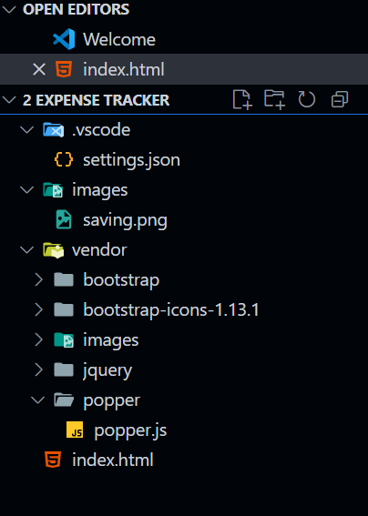

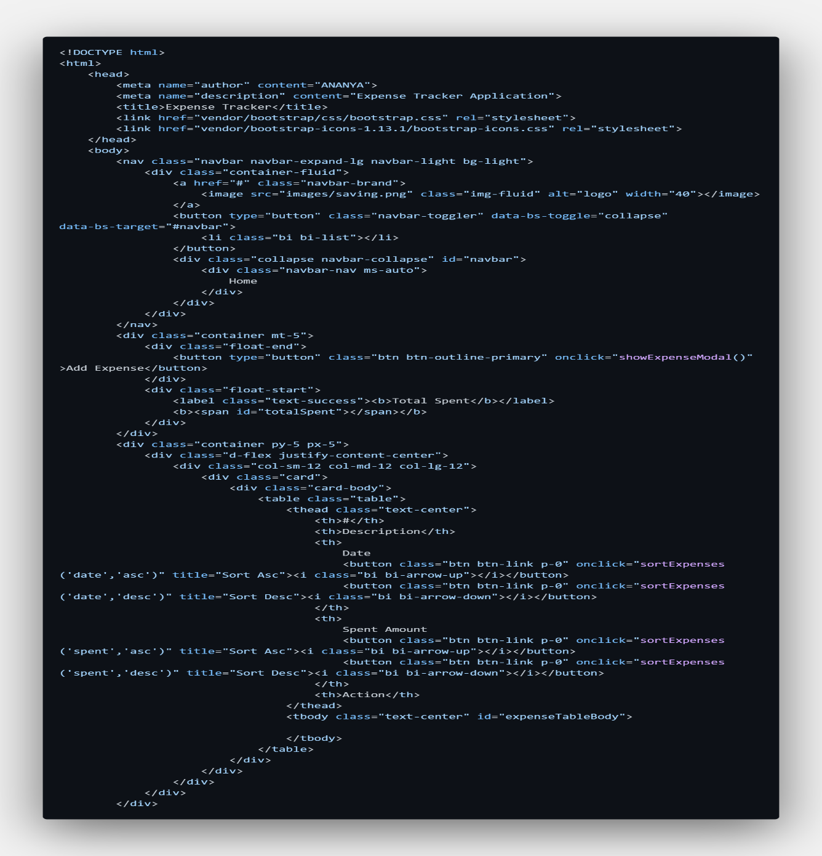
CODE

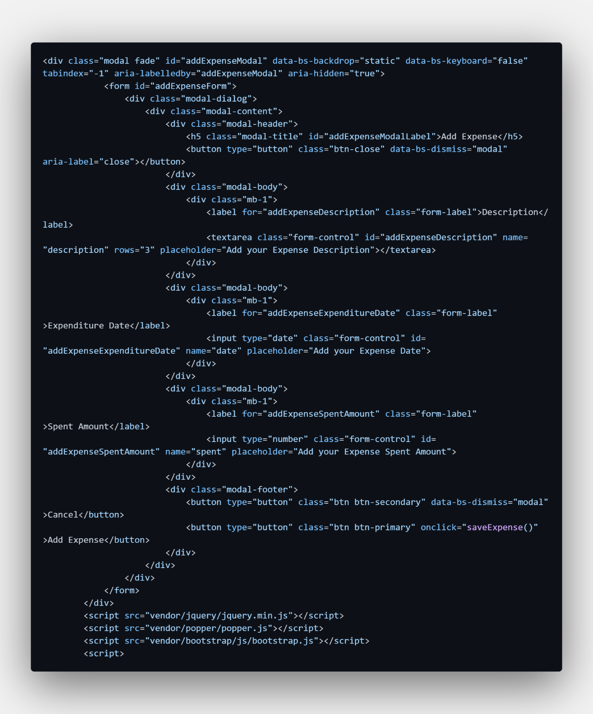
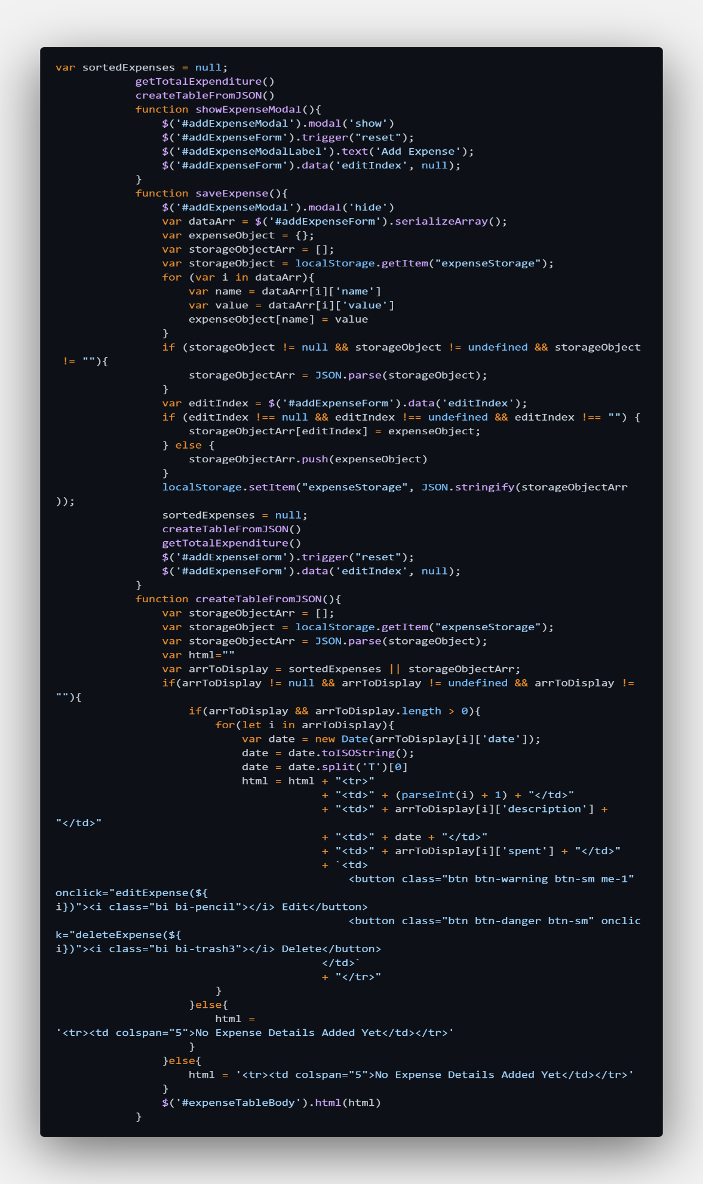
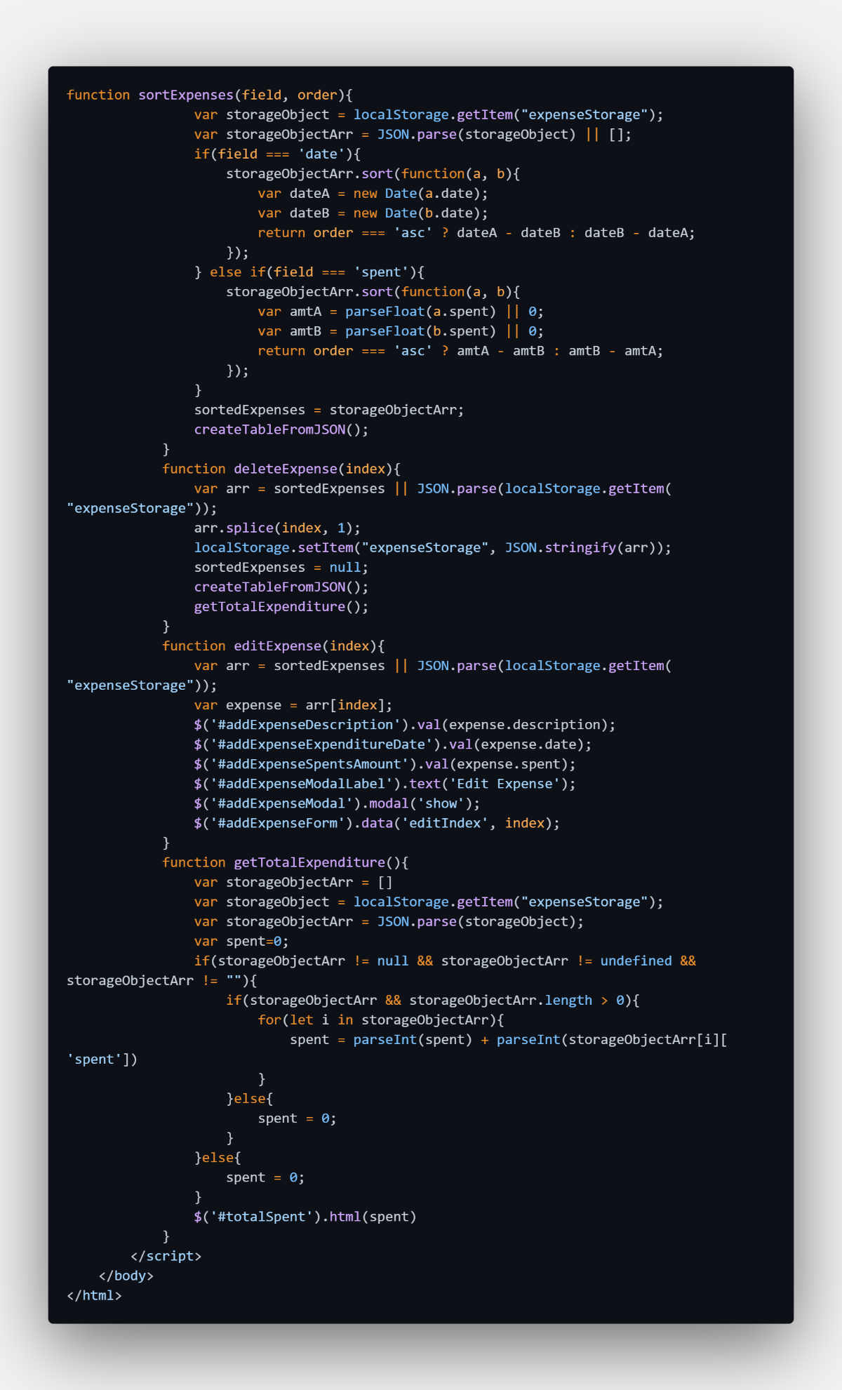
RESULTS AND OUTPUTS
This section provides screenshots of the Personal Expense Tracker application, demonstrating its key features and user interface.
1. Home Page (Initial Empty State)
When a user first opens the application, they are greeted with a clean interface. The expense list is empty, and the total is 0.
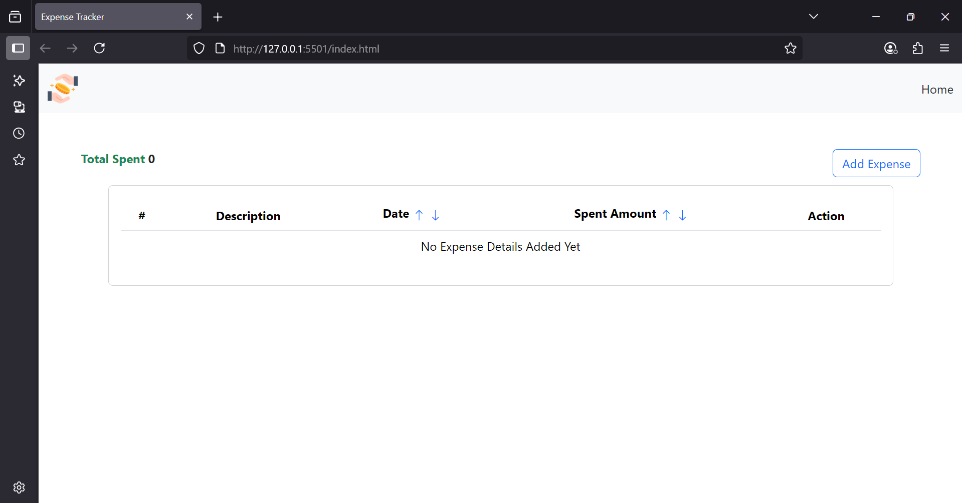

2. Add New Expense Form
Clicking "Add New Expense" button opens a modal dialog with a form to enter expense details.
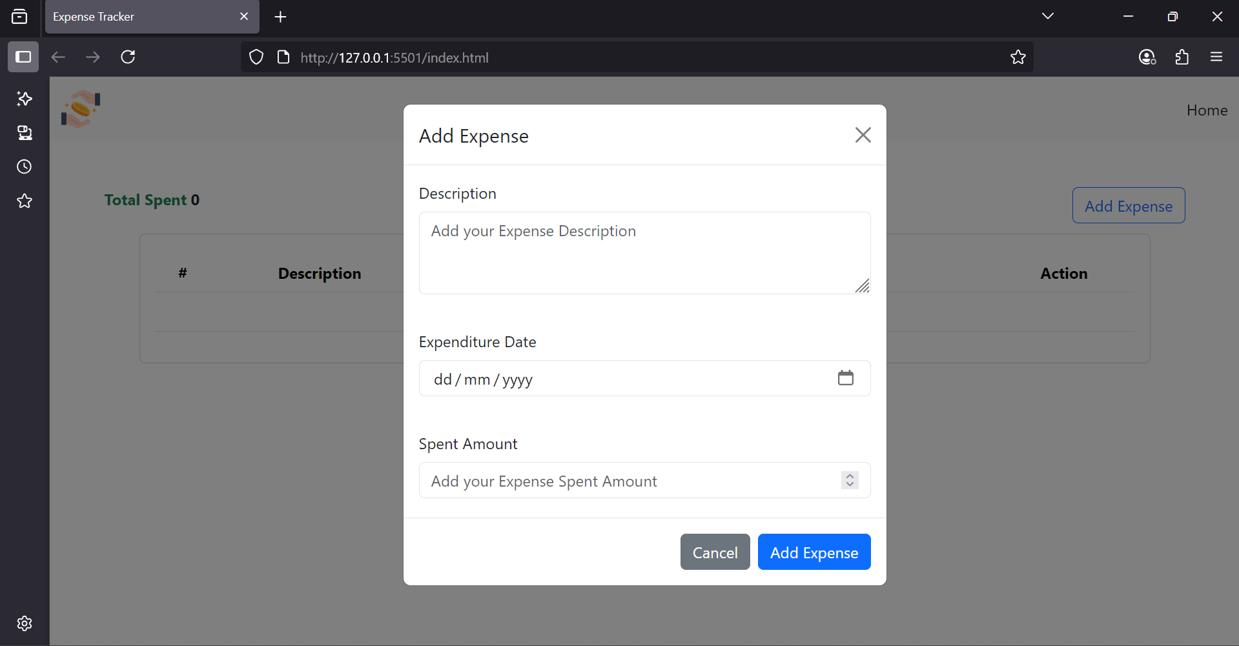

3. Filling the Expense Form
A user filling out the details for a new expense, such as "Lunch" in the ‘expense’ tab.
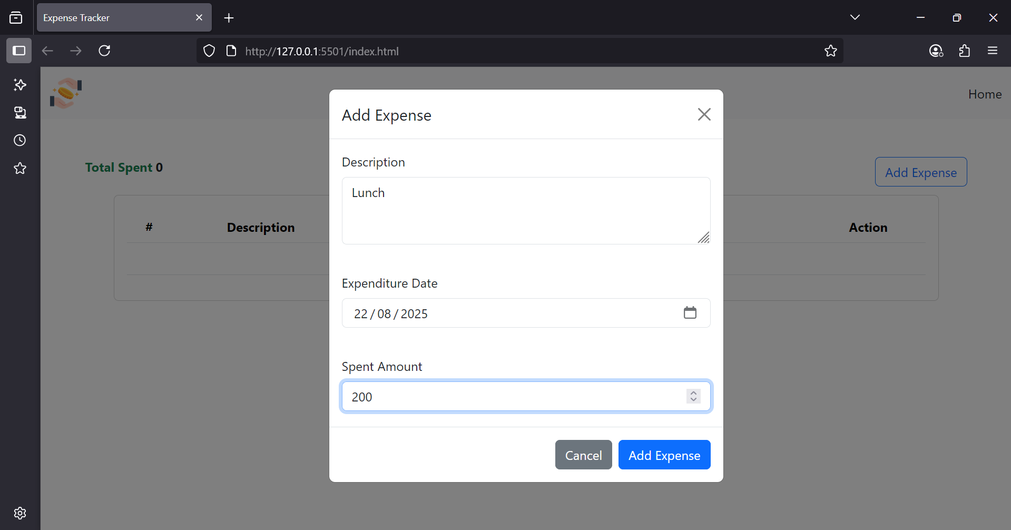

4. Displaying a Single Expense
After adding the first expense, it appears in the table on the main screen. The total expenses summary is updated accordingly. 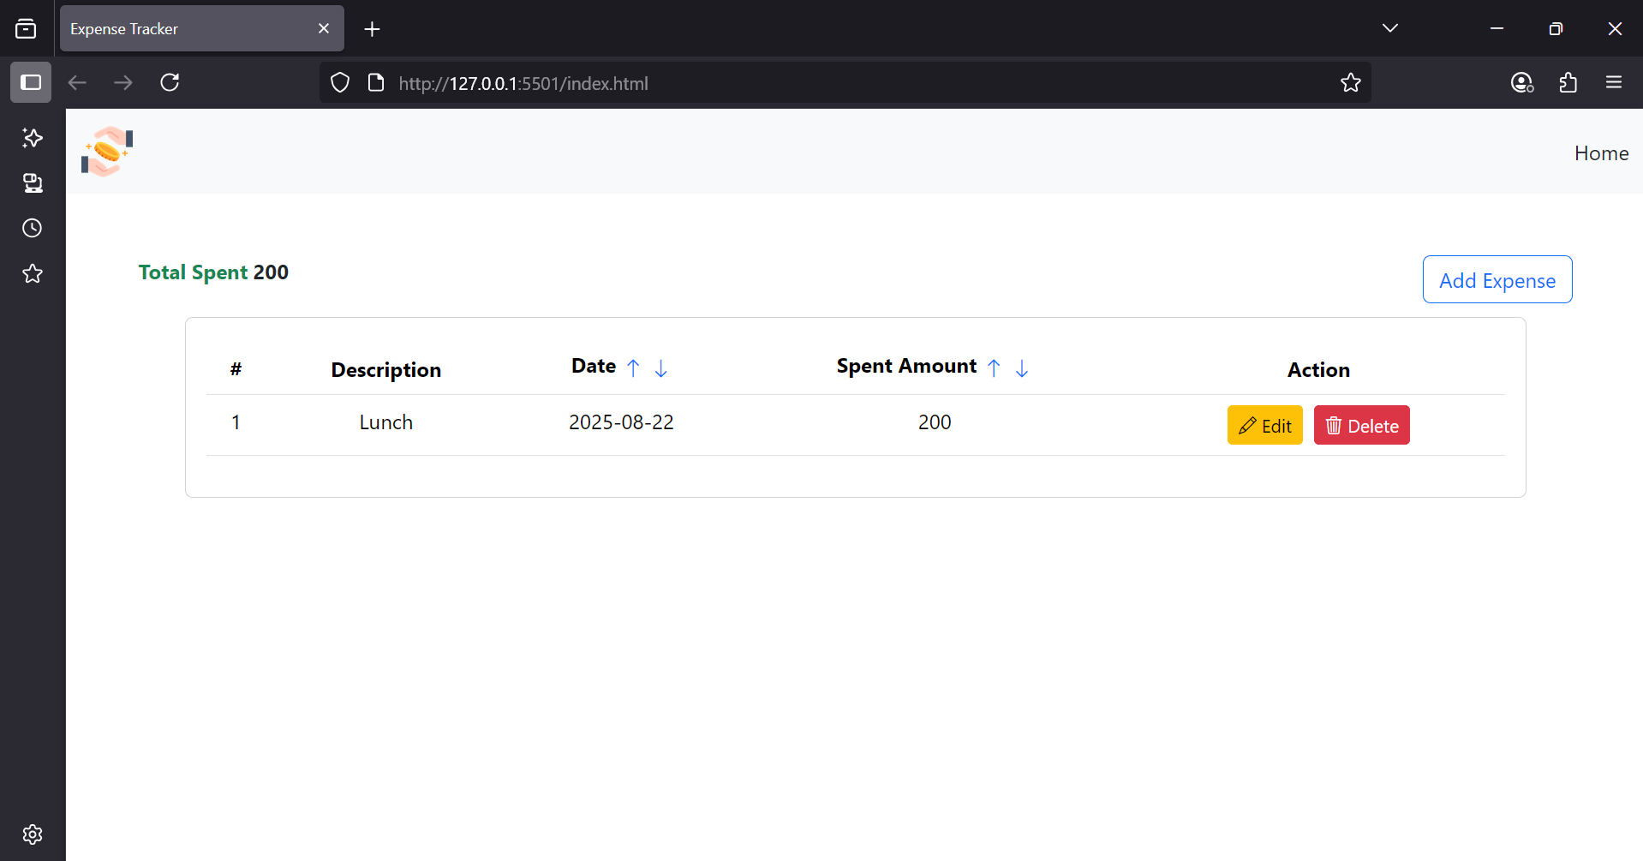

5. Displaying Multiple Expenses
The table neatly lists multiple expenses. The total summary reflects the sum of all amounts.
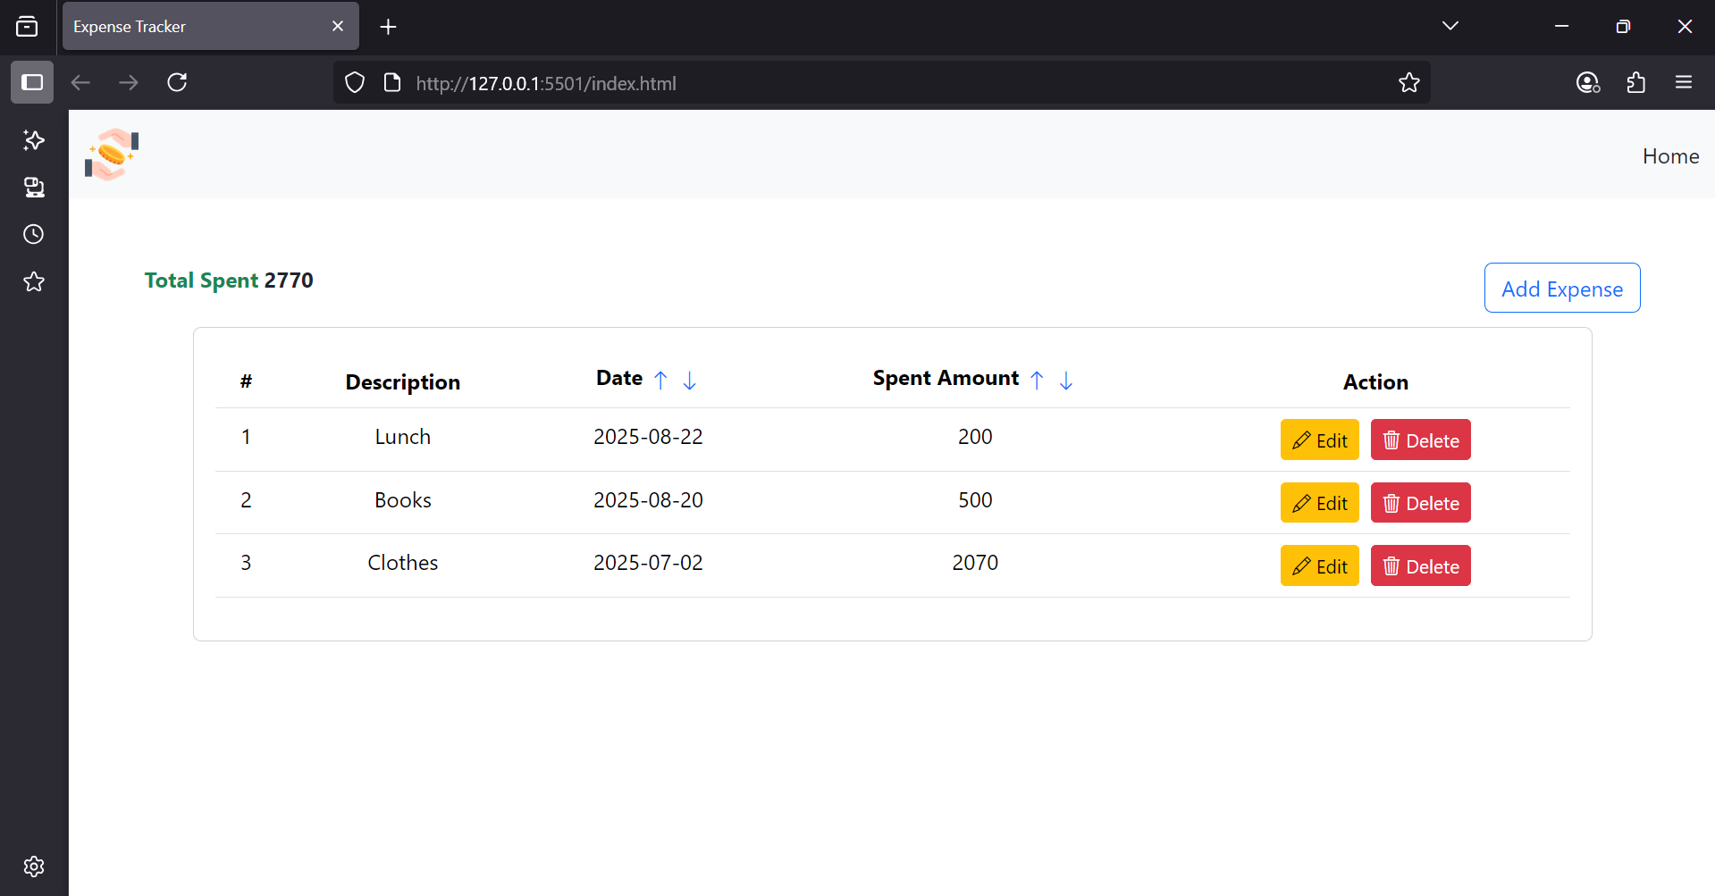

6. LocalStorage Data Persistence
The developer tools view shows the expense data stored as a JSON string in the browser's LocalStorage, ensuring data is saved across sessions.
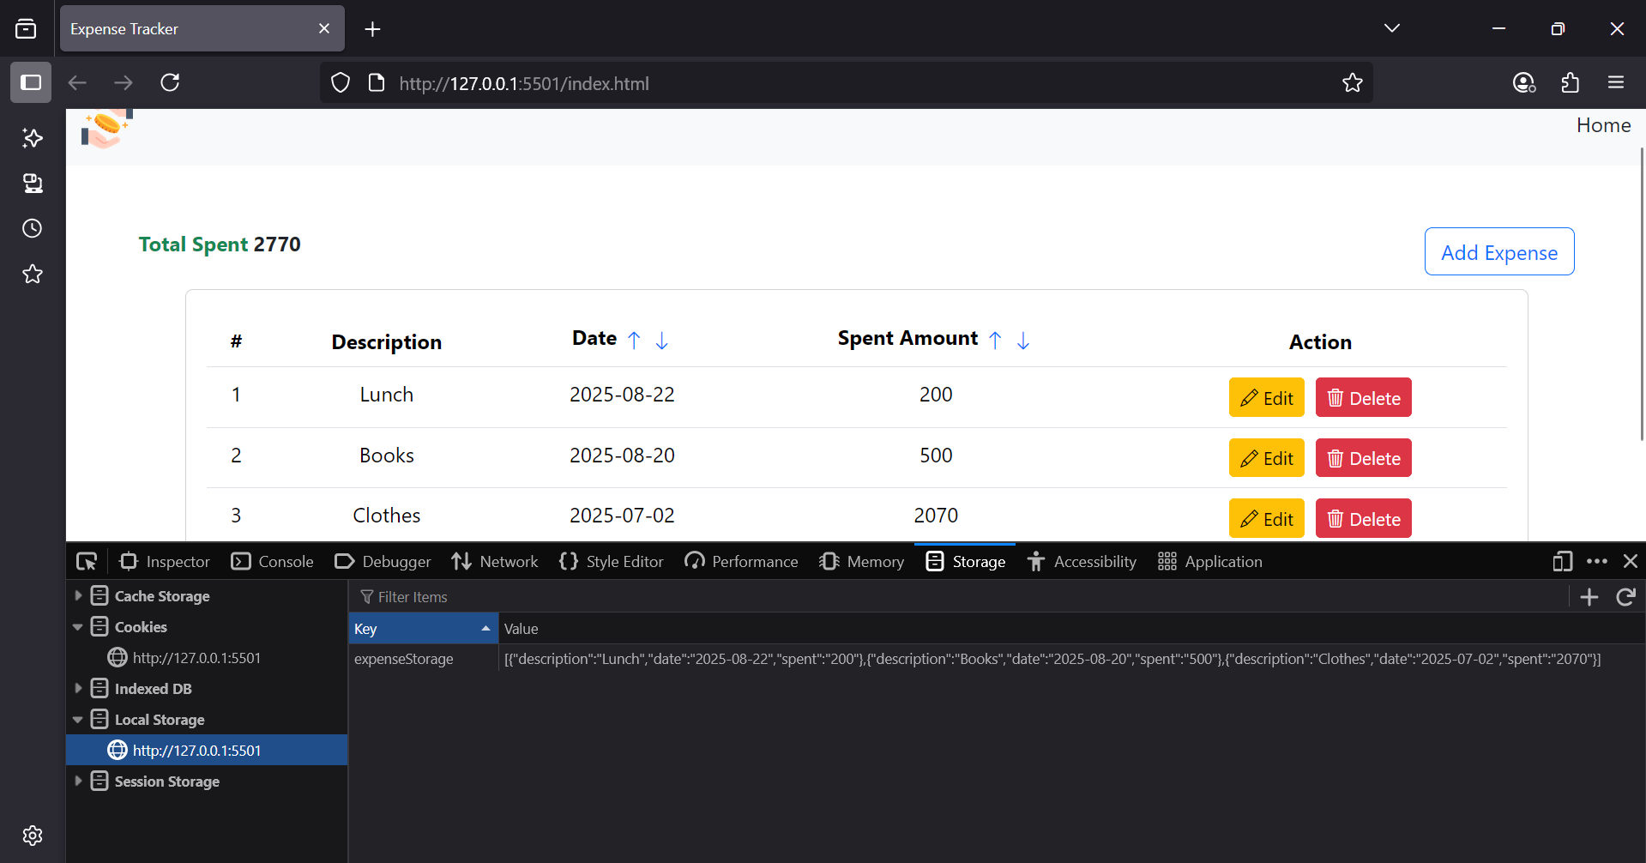

7. Filtering
The user can select the filter dropdown to view the expenses matching that time or pricewise.
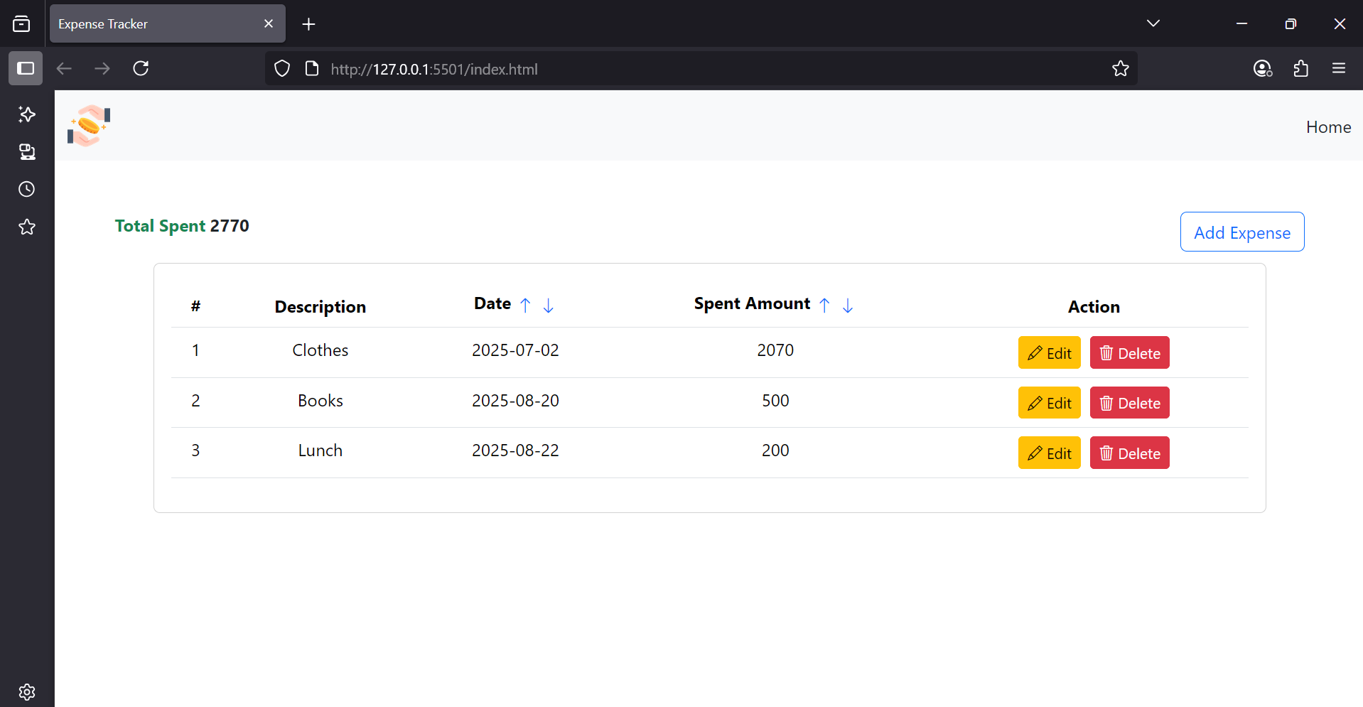
[FILTERING BY DATE]
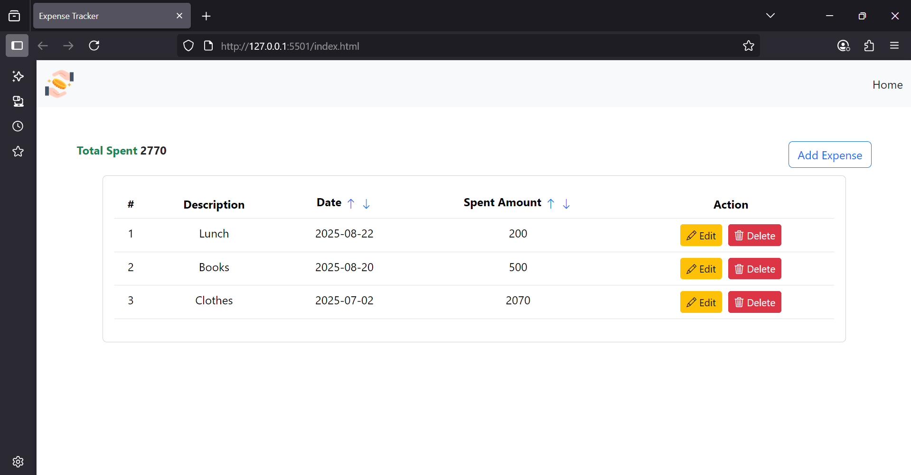
[FILTERING BY SPENT AMOUNT]

8. Edit Expense Form
Clicking the edit (pencil) icon next to an expense opens the "Edit Expense" modal, pre-filled with that expense's data.
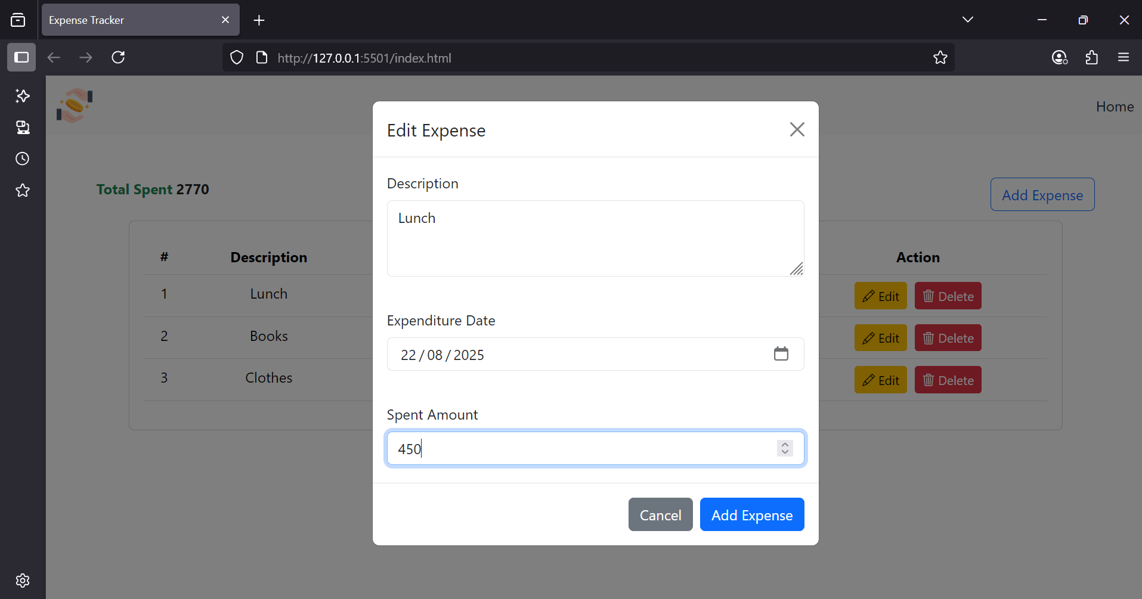9. Deleting an Expense
After clicking the delete (trash) icon, a confirmation prompt appears. Once confirmed, the expense is removed from the list and the total is recalculated.
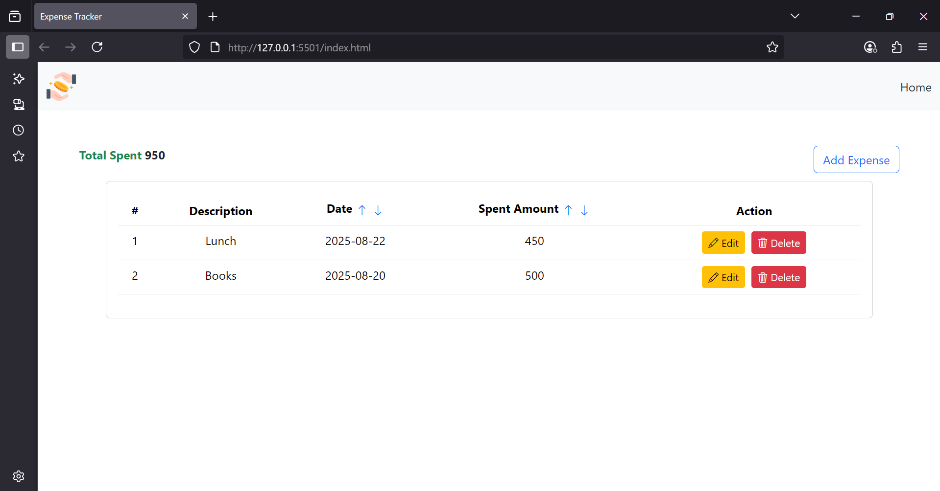

CONCLUSION
The development of the Personal Expense Tracker has successfully resulted in a functional, versatile, and user-friendly task management solution. By leveraging the synergistic power of HTML, CSS, JavaScript, jQuery, and Bootstrap 5, we have created a responsive and interactive application that empowers users to efficiently organize and manage their personal finances.
Through a structured methodology that included careful planning, wireframing, and meticulous implementation, we have ensured a seamless user experience across a variety of devices and screen sizes. The application meets all its core objectives: it allows for the complete management of expenses (add, view, edit, delete), persists data reliably using LocalStorage, and provides useful insights through expense summaries and category-based filtering.
The use of jQuery significantly simplified DOM manipulation and event handling, contributing to cleaner code and faster development. Furthermore, the Bootstrap 5 framework was instrumental in building a modern and responsive interface without extensive custom CSS.
This project serves as a strong demonstration of how client-side technologies can be used to build powerful, standalone web applications. While the current version is a robust tool, there is potential for future enhancements. These could include:
- Data Visualization: Adding charts and graphs to visualize spending habits over time.
- User Authentication: Implementing a login system to allow multiple users to securely manage their own expenses.
- Cloud Synchronization: Using a backend service (like Firebase) to sync data across multiple devices.
- Advanced Filtering: Adding options to filter by date range or amount.
In its current state, the Personal Expense Tracker stands as a valuable tool for personal and professional task management, cementing its role in promoting better financial awareness and control.

